Criminal Law

Supplement

2022

(this page intentionally left blank)

Table of Contents

Eliminative Materialism … 4

Precognitive Carousel … 9

Problems re Omissions … 10

Concepts of Accidents and Clumsiness --- 12

Willful Blindness Problem … 15

Problem re Provocation … 17

Commonwealth v. Malone … 18

People v. Wilkens … 20

Prison Time … 21

(this page intentionally left blank)

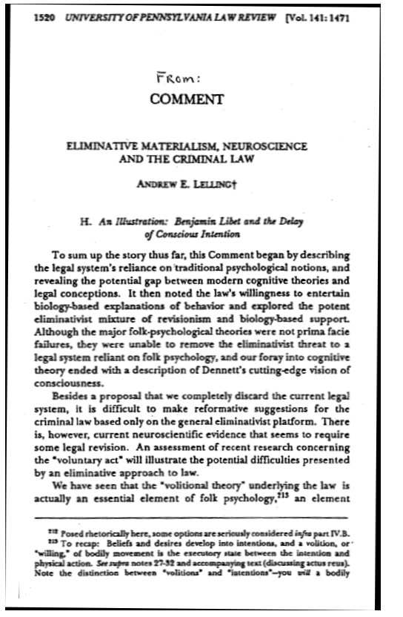

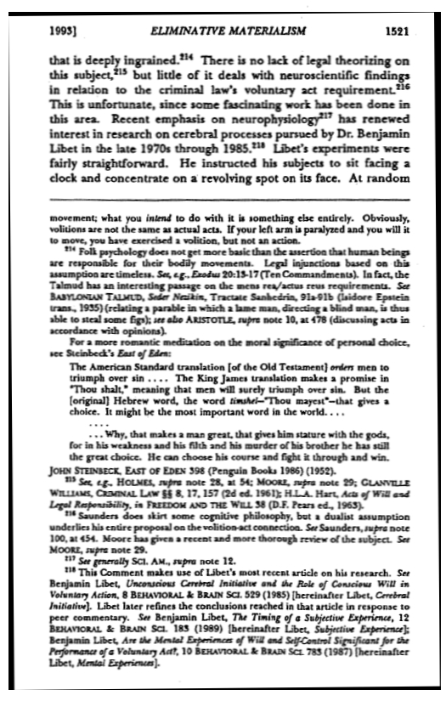
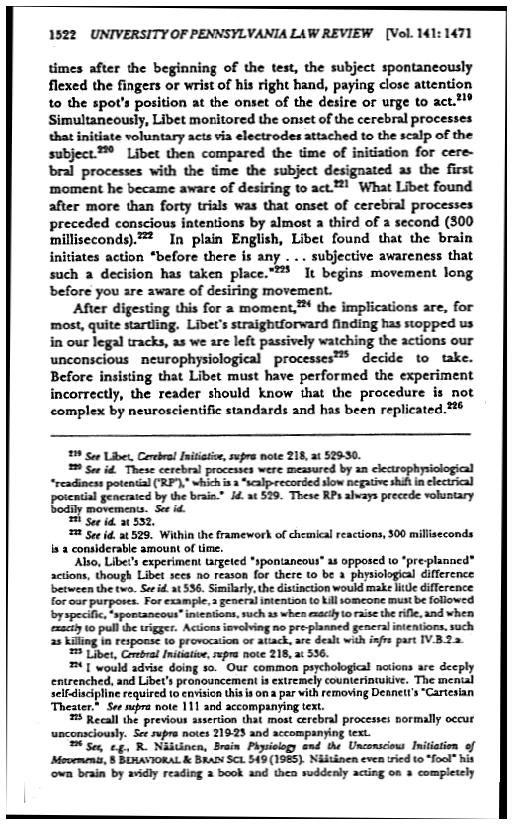
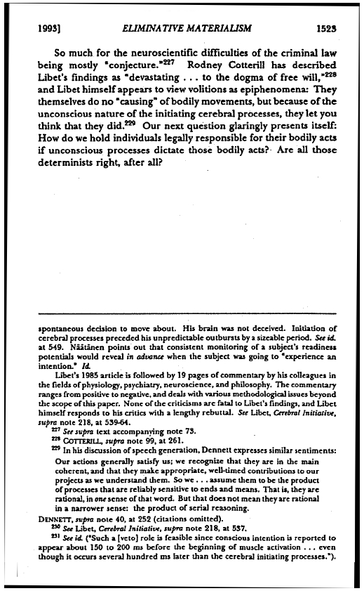
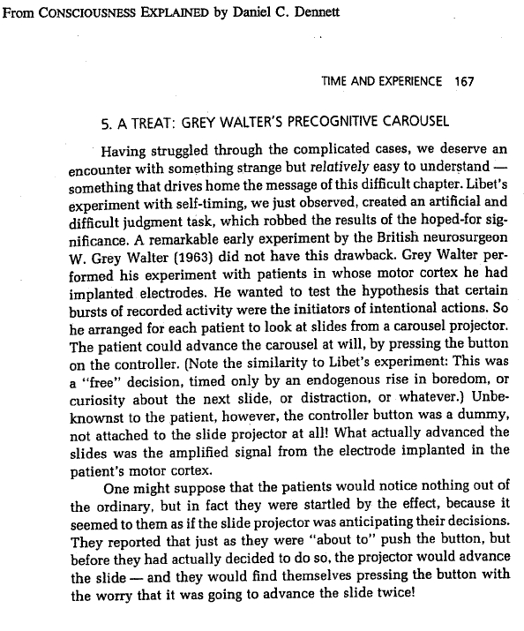
Problems re Omissions

Are any of the following individuals guilty of the crimes indicated? Should they be?

I
Richard is a medical doctor, experienced at treating serious trauma. He and his family were just heading out the door to fly to Disney World when the phone rang. The caller said that a 68-year-old woman (whom Richard did not know) had just been hit by a falling tree branch and was bleeding on the sidewalk. Not wanting to miss his long-overdue vacation, Richard said: “Find somebody else.” Somebody else was found, but by then it was too late. The coroner says the woman would have certainly lived if a skilled medical professional had treated her promptly. Is Richard guilty of homicide?

II
Harry is a dentist. He and his family were on their way out the door to attend a play when the phone rang. The caller said that her 6-year-old child (whom Harry did not know) had just broken a front tooth in a bad bicycle spill. Not wanting to miss curtain time, Harry said: “Find somebody else.” Somebody else was found, but by then the child had suffered extra hour or so of blinding pain. Is Harry guilty of child abuse?

III.
It was a cold night, and Renee was walking to Grand Central to catch the late train home. As she passed a doorway on 45th Street she heard a beggar say: "Please help me." Renee stopped briefly and looked at the man, but then she turned and went on walking. The next day the beggar was found dead, frozen in the cold. Renee was identified from a recording by a private surveillance camera at the scene. Is Renee guilty of homicide?

IV.
Donna was driving down an icy road at night when she saw a car slide out of control and over an embankment. She did not stop or make a call (her cell phone battery was very low). The person in the car was found dead, frozen in the cold. Is Donna guilty of homicide? What if Donna’s car had swerved to avoid some ice and the other car went down the embankment when its driver swerved to avoid her.

V.
Arnold was walking down the suburban residential street on which he lived. He saw one of the neighborhood children, 4 year-old Janie, getting into a car. Arnold had never seen either the car or its driver around the neighborhood before, and he did not recognize them. Later that day, the police found Janie murdered in a vacant lot on the other side town. Is Arnold guilty of homicide?

VI.
Laura had two small children. Her children and their young friends often played together in one another's backyards. By tacit agreement among the mothers, such play was under the general supervision of the mother in whose yard the children were playing. One day, Laura happened to look out the window and saw 4 year-old Janie, who lived down the street, getting into a car. Laura did not recognize either the car or its the driver. Later that day, the police found Janie murdered in a vacant lot on the other side town. Is Laura guilty of homicide?

Answer the following after you read Barber v. Superior Court:

VII.
Cases like Barber v. Superior Court allow a physician in charge of a patient to discontinue life-prolonging treatment (life support, such as respirators and intravenous feeding and hydration) if further treatment would be of no substantial benefit to the patient. On the other hand, what if a mere interloper decides to "pull the plug," or a relative does so in order to hasten an inheritance (or prevent it from being dissipated in medical bills). Would such an act, identical to the physician's, be murder? Consider the following hypotheticals:

1. Devin became the guardian of his young nephew, Seth, after the death of the child’s parents (Devin’s sister and her husband). One day, Devin heard Seth fall in the bathtub and, looking into the bathroom, Devin found him alive but face down in the water. Devin recalled that he was Seth’s sole heir and, with that thought in mind, Devin did nothing to prevent the shortening of Seth’s life, due to drowning. He did this even though he could probably have saved (extended) the child's life with ease. In other words, to secure a financial advantage, Devin omitted to do an act that would have had a significant probability of prolonging Seth’s life.

2. Devonshire Health Co. In became Patient's health insurance company by signing a contract to supply medical care. Devonshire learned that Patient had a life-threatening disease. Devonshire knew that each month that Patient continued to live expensive treatments would be required and that Patient would never fully recover and eventually die anyway. With that thought in mind, Devonshire declined to authorize treatments to prevent the shortening of Patient's life. Devonshire did this even though the company could probably have extended Patient's life with ease. In other words, to secure a financial advantage, Devonshire omitted to do an act that would have had a significant probability of prolonging Patient's life.

What is the difference between the two cases?

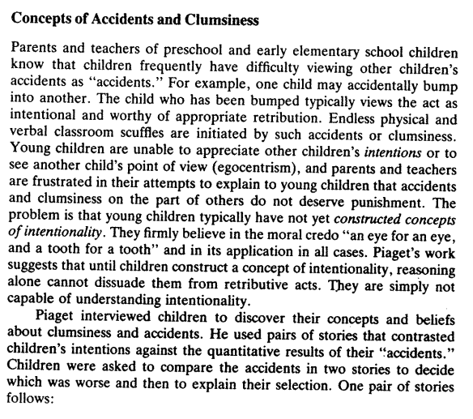
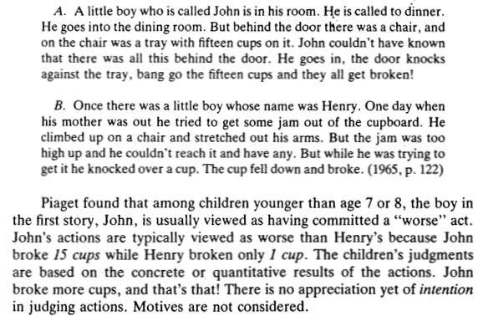

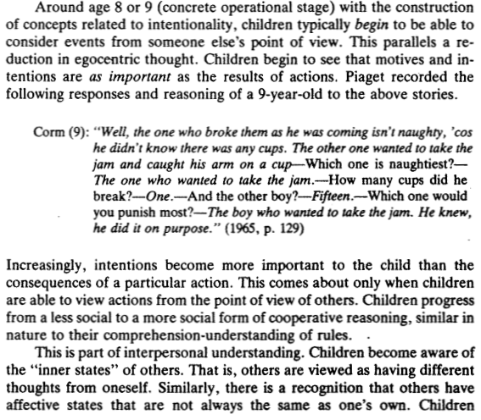

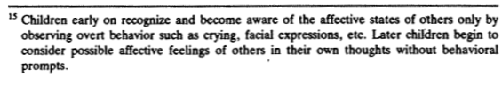
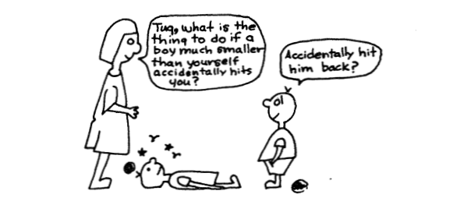

“Willful Blindness” Problem

In Ruiz v. State (2011), officers testified that they approached Ruiz on the street and politely asked him for identification. Ruiz invited the officers to his home, where his identification was located, and asked the officers to come with him. When the officers entered the home with Ruiz, they saw drugs in plain view. Ruiz then agreed to tell the police about all the drugs he had stored there.

Ruiz told a very different story. He testified that the officers approached him on the street with guns drawn, ordered him to provide identification, and then told him that if he didn’t produce ID they would arrest him. The officers then brought him to his home where they searched his entire apartment without his consent.

The trial court found the officers’ testimony credible and the suspect’s testimony not credible. The appellate court wrote:

[T]he story told by the police is unbelievable—an anonymous informant gives incriminating information; police surveillance uncovers no criminal conduct; the defendant is “nonchalantly” and “casually” approached by the police on the street; the defendant cooperatively leads the police back to his apartment to obtain his identification and invites the police inside, where a detective sees contraband in plain view, a fact certainly known to the defendant when he issued the invitation; after his arrest, the defendant tells the police about all the hidden drugs in the apartment.

Should the prosecutor be prosecuted for willful blindness in suborning the perjury of the police officers? In this connection, consider the excerpt on the next page from the Encyclopedia of Police Science (Jack R. Green, ed., 2007).

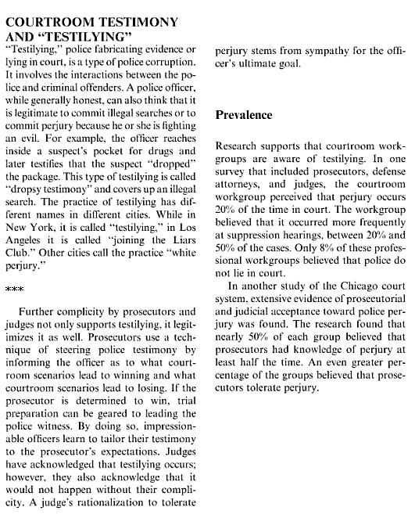

From Jack R. Green, ed., Encyclopedia of Police Science 273-74 (2007)

Problem re Provocation

Berenger is the thirteen-year old son of parents who came to this country as refugees from Sharmandia 15 years ago. He lives with his family in a neighborhood that includes a number of Sharmandians as well as people from many other ethnic backgrounds.

Because of his ethnicity, diminutive size and delicate features, Berenger has long been the target of much teasing and bullying. Constantly fearful for his personal safety, he recently took to carrying a knife in a small sheath concealed in his sock.

Coming home from school yesterday, Berenger was walking on a pathway through a vacant lot when he was set upon by a number of teenage boys. They blocked his passage and, although they did not touch Berenger, they had him surrounded. Holding their arms out, they obstructed his movement every way he turned—all the while jeering at him, calling him "Little Berry," "pretty boy" and a "dirty shard." Sharmandians have a reputation for being a very proud and explosively emotional people and they really hate being called shards. Berenger welled up with a tempestuous mixture of anger and fear. When one of the boys made an abusive comment about Berenger's mother and twisted Berenger's nose between his fingers, Berenger reached down, grabbed the knife and lashed out wildly, fatally injuring one of his tormenters before he could jump away.

The thing your boss needs to know is whether the common law doctrine of "provocation" would apply to reduce the Berenger's homicide from murder to manslaughter. Specifically, your boss asks:

1. Would the acts committed by the bullying boys qualify as provocation?

2. Would Berenger's age be relevant in determining the standard of self-control that the law would expect of him?

3. Would Berenger's Sharmandian ethnic background be relevant in determining the standard of self-control that the law would expect of him?

4. Would Berenger's Sharmandian ethnic background be relevant is assessing the gravity of the provocation? (What’s that mean?)

Commonwealth v. Malone
354 Pa. 180; 47 A.2d 445 (1946)

OPINION BY MR. CHIEF JUSTICE MAXEY
This is an appeal from the judgment and sentence under a conviction of murder in the second degree. William H. Long, age 13 years, was Killed by a shot from a 32-caliber revolver held against his right side by the defendant, then aged 17 years. These youths were on friendly terms at the time of the homicide. The defendant and his mother, while his father and brother were in the U.S. Armed Forces, were residing in Lancaster, Pa., with the family of William H. Long, whose son was the victim of the shooting.
On the evening of February 26, 1945, when the defendant went to a moving picture theater, he carried in the pocket of his raincoat a revolver which he had obtained at the home of his uncle on the preceding day. In the afternoon preceding the shooting, the decedent procured a cartridge from his father's room and he and the defendant placed it in the revolver.
After leaving the theater, the defendant went to a dairy store and there met the decedent. Both youths sat in the rear of the store ten minutes, during which period the defendant took the gun out of his pocket and loaded the chamber to the right of the firing pin and then closed the gun. A few minutes later, both youths sat on stools in front of the lunch counter and ate some food. The defendant suggested to the decedent that they play "Russian Poker". Long replied: "I don't care; go ahead". The defendant then placed the revolver against the right side of Long and pulled the trigger three times. The third pull resulted in a fatal wound to Long. The latter jumped off the stool and cried: "Oh! Oh! Oh!" and Malone said: "Did I hit you, Billy? Gee, Kid, I'm sorry." Long died from the wounds two days later.
The defendant testified that the gun chamber he loaded was the first one to the right of the firing chamber and that when he pulled the trigger he did not "expect to have the gun go off". He declared he had no intention of harming Long, who was his friend and companion. The defendant was indicted for murder, tried and found guilty of murder in the second degree and sentenced to a term in the penitentiary for a period not less than five years and not exceeding ten years. A new trial was refused and after sentence was imposed, an appeal was taken.
* * * At common law, the "grand criterion" which "distinguished murder from other killing" was malice on the part of the killer and this malice was not necessarily "malevolent to the deceased particularly" but "any evil design in general; the dictate of a wicked, depraved and malignant heart": 4 Blackstone 199. Among the examples that Blackstone cites of murder is "coolly discharging a gun among a multitude of people", causing the death of someone of the multitude.
In Pennsylvania, the common law crime of murder is divided into two degrees, and murder of the second degree includes every element which enters into first degree murder except the intention to kill: Commonwealth v. Divomte, 262 Pa. 504, 507; 105 A. 821. When an individual commits an act of gross recklessness for which he must reasonably anticipate that death to another is likely to result, he exhibits that "wickedness of disposition; hardness of heart; cruelty; recklessness of consequences and a mind regardless of social duty" which proved that there was at that time in him "that state or frame of mind termed malice" This court has declared that if a driver "wantonly, recklessly and in disregard of consequences" hurls "his car against another or into a crowd" and death results from that act "he ought to face the same consequences that would be meted out to him if he had accomplished death by wantonly and wickedly firing a gun": Com. v. Mayberry. 290 Pa. 195, 199; 138 A. 686, citing cases from four jurisdictions.

* * * "Malice in law means a depraved and wicked heart that is reckless and disregards the rights of others. Reckless conduct that results in the death of another is malice. To illustrate that: If a man fires a gun into a crowd and kills another it is murder, because the fact of the reckless shooting of a gun into a crowd is malice in law. That wicked and depraved disposition and that recklessness and disregard of human life is malice." [Similarly], "When a man uses a gun loaded with powder and shot and aimed at a vital part of the body of another and discharges it, he must be presumed to know that death is likely to follow." In Com. v. Arnold, 292 Pa. 210 at 213; 140 A. 898, this court said: "Malice will be implied from conduct, recklessness of consequences, or the cruelty of the crime".
* * *
The jury found that the killing [in this case] was neither intentional nor accidental but that it was a malicious killing though without a specific intent in the killer to take life, and that, therefore, it was murder in the second degree.
* * *
The killing of William H. Long by this defendant resulted from an act intentionally done by the latter, in reckless and wanton disregard of the consequences which were at least sixty per cent certain from his thrice attempted discharge of a gun known to contain one bullet and aimed at a vital part of Long's body. This killing was, therefore, murder, for malice in the sense of a wicked disposition is evidenced by the intentional doing of an uncalled-for act in callous disregard of its likely harmful effects on others. The fact that there was no motive for this homicide does not exculpate the accused. In a trial for murder proof of motive is always relevant but never necessary.
All the assignments of error are overruled and the judgment is affirmed. The record is remitted to the court below so that the sentence imposed may be carried out.

People v. Wilkins
Court of Appeal of California
2011 Cal. App. LEXIS 14 (2011)

It has long been recognized in this state that “[t]he purpose of the felony-murder rule is to deter felons from killing negligently or accidentally by holding them strictly responsible for killings they commit. [Citations.]” (People v. Washington (1965) 62 Cal.2d 777, 781, italics added.) Defendant committed a burglary of a residence under construction before workers arrived to begin their day. He loaded the back of his pickup truck with numerous boxed appliances and fixtures. He stuffed the cab of the truck to the windows with smaller items. In his haste to leave the scene unnoticed, he left the tailgate on the truck down and did not tie down the loot loaded into the bed of the truck despite the fact that he had ties in his truck. Sixty miles later on his drive home where he would unload the loot, the stove defendant stole fell off the back of his truck, resulting in the victim’s death. The jury convicted defendant of first degree murder under the felony-murder rule. He contends, inter alia, that the evidence does not support his conviction and that the court erred when it refused to instruct the jury that a burglary is complete upon the perpetrator reaching a place of temporary safety.

Although defendant was, by all accounts, driving normally and his crime had not yet been discovered, defendant committed the acts that resulted in the death while he was at the scene of, and in the process of committing, the burglary. The acts that caused the homicide — the failure to tie down the load of stolen loot and raise the truck’s tailgate — occurred at the scene of the burglary, not 60 miles later when part of the unsecured load fell off the back of the defendant’s truck as he drove to where he could unload and hide the haul. As a result, it was not unreasonable for the jury to conclude the homicide and the burglary were part of one continuous transaction, inasmuch as defendant was in flight from the scene with his license plates secreted.

* * *
We do not find a sentence of 25 years to life for a first degree murder under the felony-murder rule to be grossly disproportionate under the Eight Amendment.

* * *
The judgment is affirmed.

Prison Time
By Michael G. Flaherty

In everyday life, losing track of time often signals enjoyment and liberation from the clock and calendar. While on vacation, for instance, you may not know (or care) what day it is. People can also lose track of time when engaged in a challenging but enjoyable activity, such as surfing or composing music. Yet, in concussion assessment protocols, not knowing the time of day can indicate damage to one’s brain, and questions about the date are used in the clinical diagnosis of dementia. Due to the cultural standardization of our temporality, losing track of time – for positive or negative reasons – is an abnormal experience for most people.
Among prisoners, in contrast, losing track of time is characteristic of temporal experience. They quickly learn that this distortion in the perception of time is endemic during their captivity due to an unchanging environment and the sameness of each day.
Stimulus deprivation is a standard feature of incarceration. In his prison memoir From the Inside (2003), Robert Berger laments:
I wake up in the same room every day, put on the same color clothes, eat at the same table in the mess hall with the same people, walk in the same compound and look at the same scenery day in and day out, year after year.
In her memoir Orange Is the New Black (2010), Piper Kerman corroborates the problematic connection between temporal experience and the unrelenting emptiness of maximum lockdown:
It was easy to lose track of what day it was – there were no newspapers, no magazines, no mail, and since I avoided the TV rooms, no significant way to tell one day from the next … there were no clear windows, so I couldn’t even watch the progression of the sun.
If convicts attempt to ‘solve’ the problem by keeping track of standard time using clocks and calendars, they succeed only in sensitizing themselves to the fact that nothing is happening and, in prison (as in everyday life), this makes for the excruciating experience of protracted duration – that is, the perception that time is passing very slowly.
Prisons are tantamount to a vast diabolical experiment on how brutality and boredom condition temporality. The many ways that people suffer time within the context of involuntary confinement have important implications for our understanding of how human beings, always and everywhere, perceive the passage of time and strive to manage their temporal experience. Ironically, then, there is a timeless quality to our investigation of temporality among prison inmates. In fact, far from being unrepresentative and irrelevant, their extreme circumstances provide insight into diverse dimensions of time, making more apparent essential – but often obscured – features of human temporal experience.
Intervals of time that are empty of change and activity are experienced as slow in passing but, with little or nothing to remember, they soon evaporate in memory and seem to have passed quickly. This paradoxical dynamic operates inside and outside of prison, but it is greatly exacerbated by the relentless tedium of incarceration. ‘Time crawled through this desert of uneventfulness as though lame in both feet,’ recalls Arthur Koestler in his autobiographical account of solitary confinement, Dialogue with Death (1937). In hindsight, however, he is astonished to find that ‘these interminable hours, days and weeks passed more swiftly than a period of times has ever passed for me before…’ Among prisoners, then, losing track of time might be almost functional, insofar as it condenses the unpleasant memory of suffering through long stretches of empty time.
However, this functionality is offset by disorientation and resulting anxiety when one loses track of time. Prisoners and non-prisoners alike have been socialized into the standardization of time since childhood, and, even many years later, that process leaves us feeling quite uncomfortable when we do not know what time it is. Intuitively, we realise that losing track of time desynchronises us and impedes our ability to coordinate our actions with others. This disorientation became apparent when many of us lost track of time during the blurred days of social isolation occasioned by the COVID-19 pandemic, and it is clear that people found the resulting distortion in temporal experience profoundly unsettling. Online memes created during the period of social isolation lament too much eating, too much drinking, and disastrous experiments with our appearance – much of it in an effort to fill undifferentiated intervals of time.
More than most people, prisoners are beset by temporal quandaries. They must traverse a huge expanse of unstructured time, and there are few distractions with which they can occupy themselves. Like most people, they are reluctant to lose track of time, but attention to clocks and calendars will only stretch the perceived length of their sentences. Thus, prisoners engage in what I call ‘time work’ by crafting personal or collective efforts to modify their own temporal experience.
Before I embarked on this study of temporality in prison, my research concerned how the perceived passage of time is shaped by one’s circumstances. Yet the data revealed that people often provoke or cultivate desirable forms of temporal experience and suppress or minimise undesirable forms of temporal experience. For example, one might engage in a distracting activity in order to make time seem to pass more quickly, or try to slow down and concentrate on details of the present moment to make it last longer. Conceptualizing such tactics as time work, I showed that we are architects as well as victims of time – which, as it turns out, is also true behind bars.
Prisoners develop characteristic methods for marking time as an adaptation to their circumstances. Given that the available resources for time reckoning are so meagre, they take advantage of the rhythms and procedures of the temporal regime. Correctional officers impose a strict schedule on convicts, including meals, recreation, overnight lockdown and so forth. This invariant timetable structures temporal experience for prisoners. In his autobiography You Got Nothing Coming (2002), Jimmy Lerner recalls:
There are no windows in my cell, and of course they took my watch, but I can estimate the time by the food trays. Three times a day an unseen hand shoves a plastic tray through a slot in the bottom of the solid steel door.
His time in ‘Suicide Watch Cell No 3’ is a featureless terrain, aside from the contents of each tray:
If it’s a handful of Rice Krispies and a dented orange (invariably encrusted with a thick white mould), then it must be breakfast time … Peanut butter and jelly means it’s about noon, and macaroni and cheese must signify Happy Hour here on the nut wing of the Las Vegas county jail.
Correctional officers also count prisoners several times each day, and this security procedure creates temporal structure. Each count brings all activity in the penitentiary to a halt, as Kerman describes:
The five of us stood silent by our bunks, waiting. The entire building was suddenly quiet; all I could hear was the jangling of keys and the thud of heavy boots. Eventually a man stuck his head into the room and… counted us. Then, several seconds later, another man came in and counted us.
This happens multiple times every day and, when the count is wrong, the whole process is repeated until they get it right. Likewise, prisoners are released from their cells for showers, talking on the telephone, shopping at the canteen, or ‘yard’ (ie, recreation) according to an invariant schedule, thereby producing a circular system of time reckoning where a linear sequence of specific dates is largely irrelevant.
The temporal regime provides a skeletal structure for time reckoning but, each day, the vast majority of prisoners still confront a daunting stretch of unscheduled hours. Desperately, ingeniously, they formulate personal routines with which to fill these otherwise empty intervals.
In her memoir Stolen Time (2007), Sunny Jacobs exemplifies the self-conscious intent of this strategy:
I created a routine for myself. It helped to overcome the feeling of being detached, of free-floating in the absence of a time structure.
Awakened by the ‘smell and sounds of breakfast’, she would ‘wait by the door with my face pressed sideways to the 5” x 5” square of safety glass criss-crossed with wire’. Once the guard arrived with the breakfast cart, she would exercise, eat, and then go back to sleep (another tactic for shortening the perceived length of one’s sentence). The rest of her morning would be devoted to yoga, prayer, and meditation. ‘Lunch was another marker in the passage of timelessness,’ Jacobs writes, after which she ‘would write or draw or do maths problems in my head or think about my children, Jesse, my family and cry.’ These practices bring her to another meal, but one that is merely followed by relentless repetition.
With inventiveness born of necessity, prisoners try to distract themselves from the excruciating march of time. They mold chess pieces from toilet paper and toothpaste; they carve dice for backgammon from paracetamol tablets. Or, as Albert Woodfox observes in his autobiography Solitary (2019), they endeavor to interrupt the dreadful sameness of each day by improvising a bit of novelty:
I tried to make the routine different. I might sit on my bunk to eat breakfast for months or maybe a year. Then I’d stand to eat breakfast for months. Then I’d sit at the table to eat breakfast. Deep down I always knew it was the same routine. I couldn’t really trick myself into believing otherwise.
Where such options are available, convicts also attempt the long-term acceleration or differentiation of temporal experience by means of exercise and hobby activities, as well as (frequently cynical) participation in religious, educational or therapeutic programs. Despite creativity and diligence, however, such efforts are akin to the struggles of someone drowning in an ocean of time.
Incarceration is fascinating because, at the heart of it, there is something essential to the human condition: an existential struggle to enjoy one’s life even within the most harsh and hostile circumstances. Prisoners are obsessively engaged in time work because, here and there, now and then, they are able to modify their temporal experience in desirable ways. Yet we must not overstate this capacity, for throughout captivity their success is always localized and fleeting; they may win battles, but they lose the time war.
* * *

From Psyche. https://psyche.co/ideas/prison-life-puts-the-time-work-we-all-do-into-sharp-relief

http://www.4dca.org/opinions/Jan%202011/01-12-11/4D09-1544.op.pdf. This above statement of the case is substantially quoted from a blog entry by Orin Kerr, Police Officers Committing Perjury in Testimony About Consent Searches?, in The Volokh Consipiracy, http://volokh.com/2011/01/17/police-officers-committing-perjury-in-testimony-about-consent-searches/ (January 17, 2011.
It has been explained that "Russian poker" is a game in which the participants, in turn, place a single cartridge in one of the five chambers of a revolver cylinder, give the latter a quick twirl, place the muzzle of the gun against the temple and pull the trigger, leaving it to chance whether or not death results to the trigger puller.

