Finder’s Rights

Hierarchy of entitlement to possession:
True Owner
Earliest known possessor other than T.O.
2nd earliest known possessor other than T.O.
3rd earliest known possessor other than T.O.
4th earliest known possessor other than T.O.
.
.
.
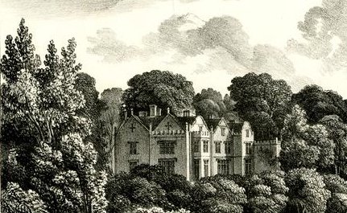
Elwes case:

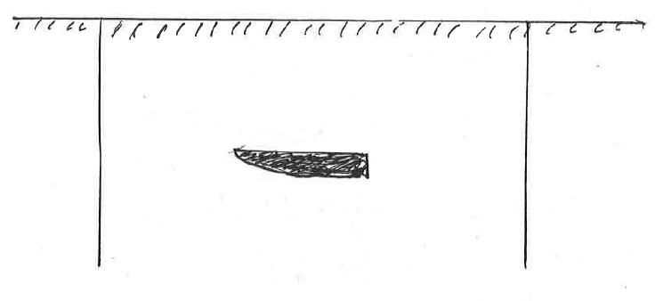
Bridges v. Hawksworth:

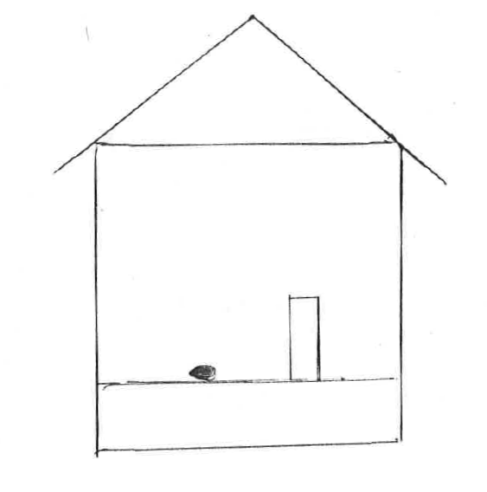
Bridges v. Hawksworth (alt):

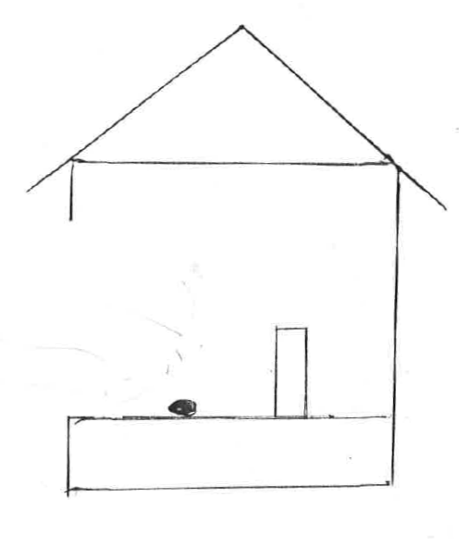
Finders Rights (cont’d):

Traditional (“English”) Rule:
earliest known possessor (incl. “unconscious”)
prefers -- O of locus in quo
exception -- public/semi-public places
(See note 3, p. 104)

Many American cases (“American Rule”):
earliest known possessor but, seemingly,
only conscious possession “counts”
Prefers -- finder
Exception -- “trespass”

Lost vs. mislaid property

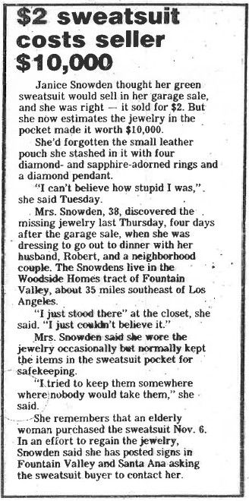

11/18/82
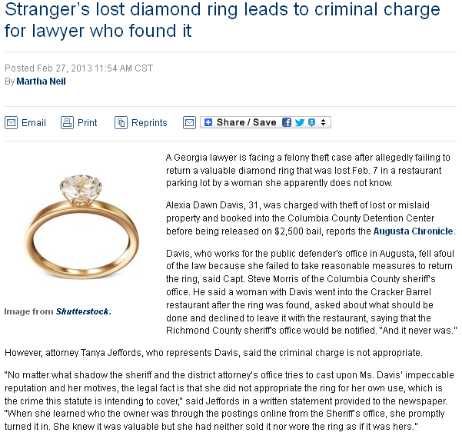

http://www.abajournal.com/news/article/lawyer_is_criminally_charged_re_diamond_ring_lost_by_stranger_in_parking_lo/?utm_source=maestro&utm_medium=email&utm_campaign=weekly_email

Finders Rights:

Lost

Mislaid

Treasure Trove

Abandoned Property

Bailments

Transfer of possession (bailment)
• a physical event
• requires intent of transferee (transferor?)
• intent manifested by exerting
dominion & control

Transfer of title (gift, sale, etc.)
• non-physical (ideational)
• requires intent of transferor/transferee
• any objective manifestation of intent

Bailments:
“possession of goods owned by another”
• bailee agrees to take possession
• Strict liability for conversion
• Strict liability for “misdelivery”
• Liability for other loss only if negligent
• presumption of negligence
• acceptance of bailment + loss
• rebuttable (how?)

Kinds of Bailments: Liability:
• Sole benefit of B’or • Gross negligence
• Reciprocal benefit • Ord’y negligence
• Sole benefit of B’ee • Slight negligence

Containers with unknown contents
• “no agreement, no bailment”
• “container, hence contents”
• “constructive” knowledge

Parking lots??

Personal agreement or entrusting

Jus tertii
• possession is title as against a wrongdoer
• rights as between B’ee and B’or
• rights of wrongdoer, once having paid full dmgs

Problem
Bailments & Jus Tertii

Robert lends his car to his sister, Ellen, who needs it for a doctor’s appointment. On her way home, Ellen is broadsided by McKinley, who negligently ran a red light. Ellen is not injured but the car sustains $3000 of damage.

1. Can Ellen recover the $3000 from McKinley?

2. Can Robert recover the $3000 from McKinley?

3. Can Robert recover the $3000 from McKinley after Ellen does?

4. Can Robert recover the $3000 from Ellen?

5. Can Robert recover the $3000 from Ellen before she recovers anything from McKinley?

6. Can Robert recover the $3000 from McKinley if Ellen settles with McKinley for $2000?



